**Batch: C2 Roll No.:16010122257**

**Experiment No. 03**

|  |
| --- |
| **TITLE:** **Demonstrate the use of Bootstrap** |

AIM: To use bootstrap (open source front-end development framework) for the creation of web pages.

**______________________________________________________________________**

**Expected Outcome of Experiment:** Re_design of web pages using various HTML, CSS tags with bootstrap.

**_______________________________________________________________**

**Books/ Journals/ Websites referred:**

http://getbootstrap.com/getting-started

**_____________________________________________________________________**

**Problem Statement:**

1. **Students have to re-design web-pages developed in Experiment 1 and 2 by using bootstrap.**
2. **Create a webpage using bootstrap with following features,**

i) use a container to set the content's margins dealing with the responsive behaviors of layout.

ii) shape the image into a circle

iii) use bootstrap grid system

iv) create basic pagination

v) insert search icon(glyphicon)

**Description of the application implemented with output**:

HOMEPAGE:

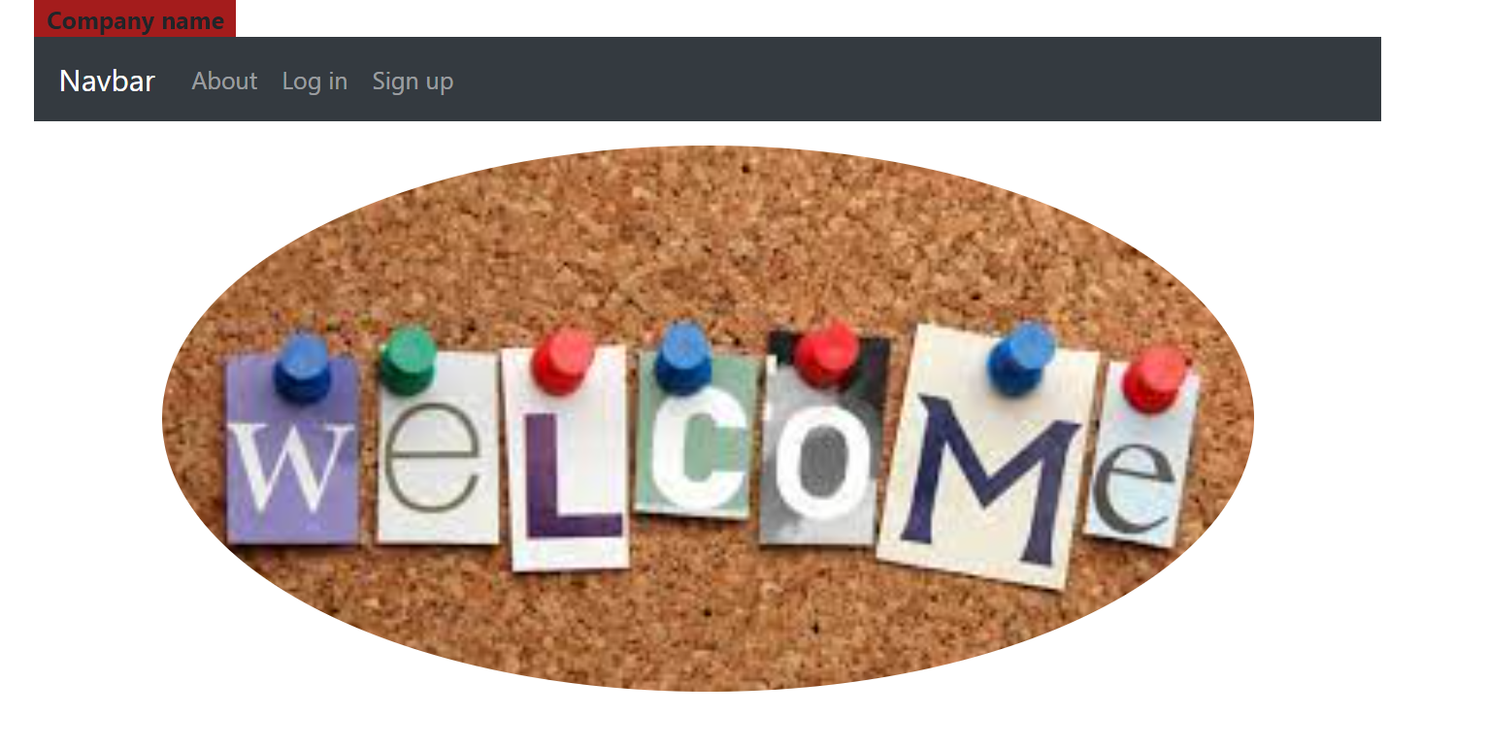

**CODE:**

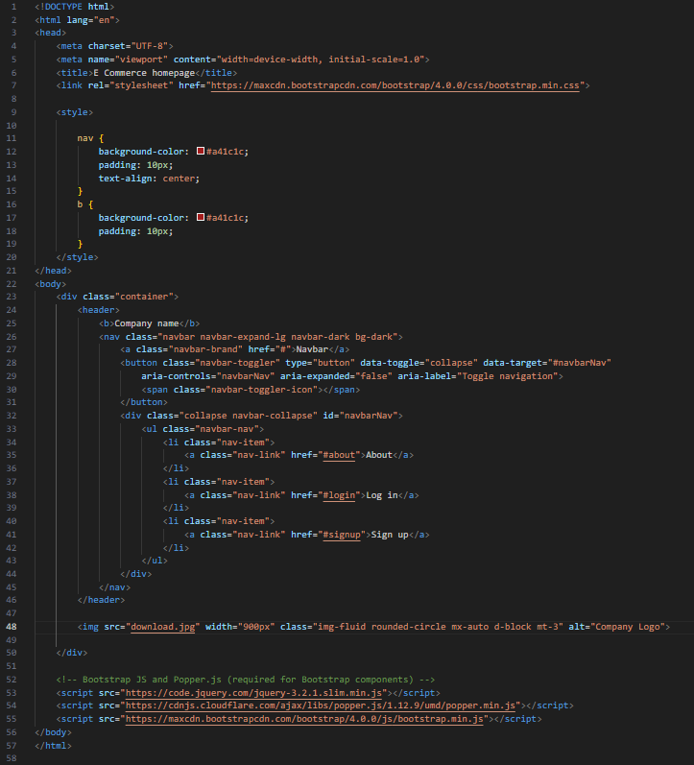

**LOGIN:**

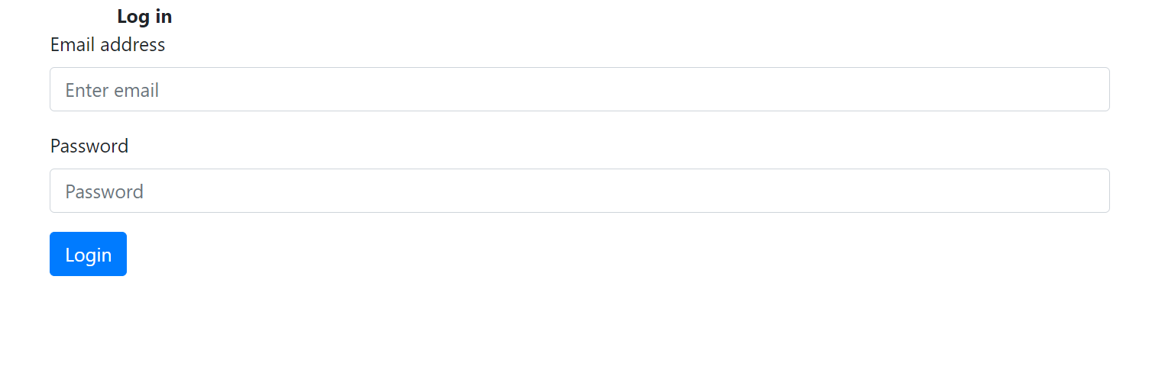

**CODE:**

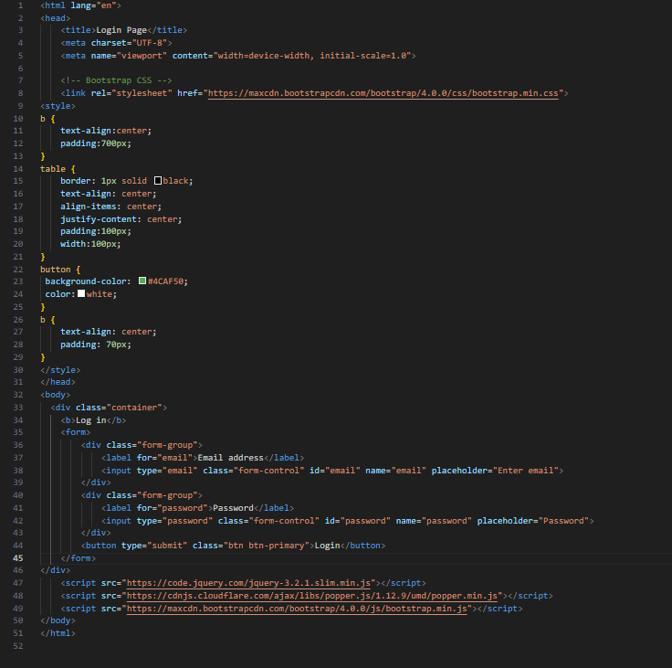

**SIGNUP:**

**CODE:**

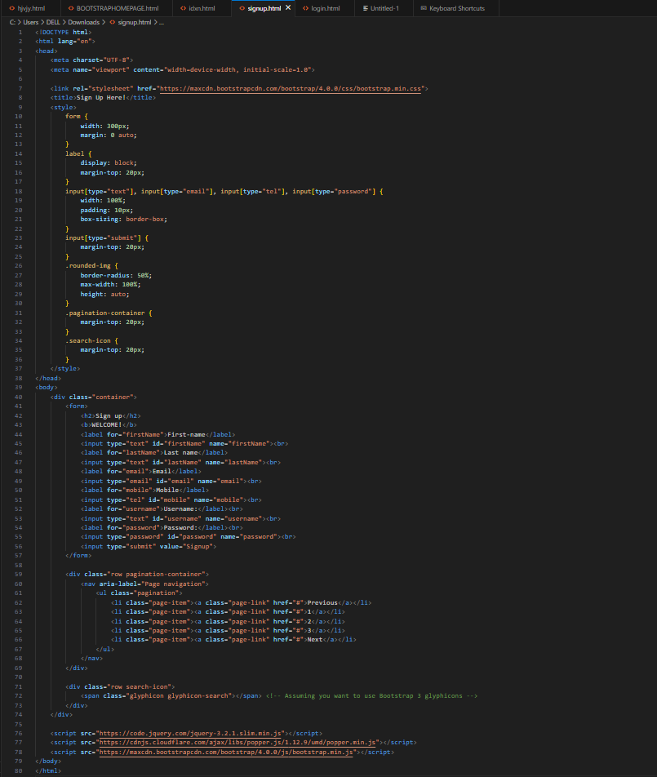

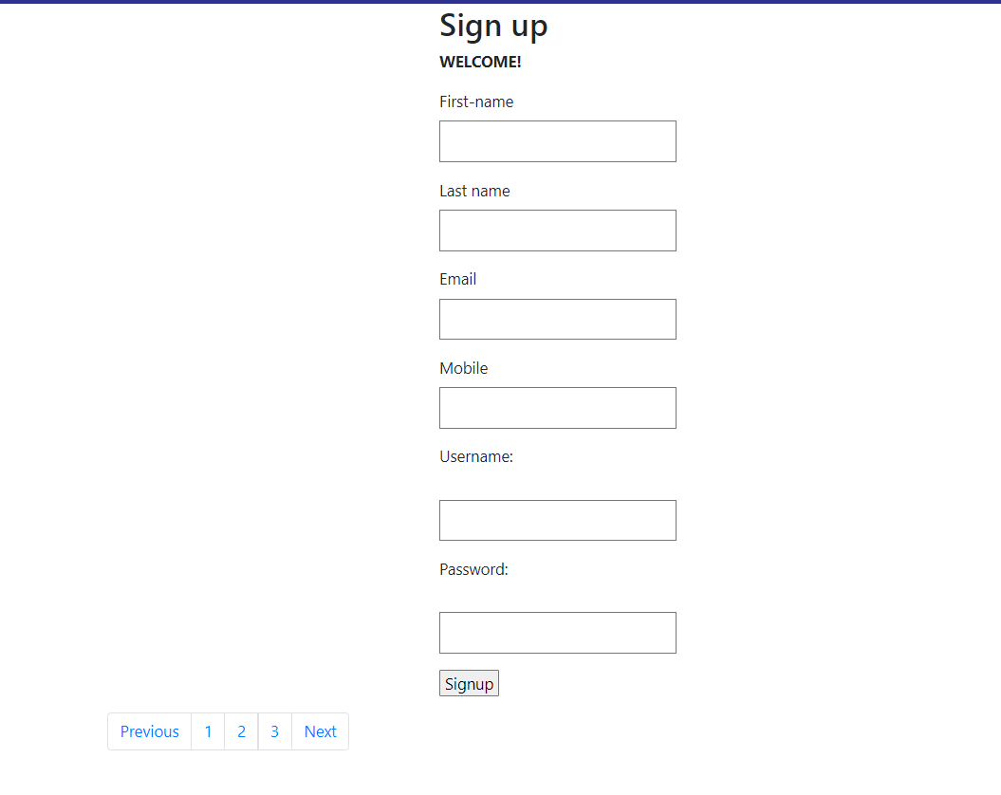

**TIMETABLE:**

**CODE:**

<!DOCTYPE html>

<html>

<head>

    <title>TABLES</title>

    <link rel="stylesheet" href="https://maxcdn.bootstrapcdn.com/bootstrap/4.0.0/css/bootstrap.min.css">

    <style>

        table, th, td {

            border: 1px solid black;

            text-align: center;

            box-shadow: 0px 8px 16px 0px rgba(0,0,0,0.2);

            background-color: #f2f2f2;

            font-size: 0.8em;

        }

        th, td {

            padding: 10px;

            text-align:center;

        }

        .center-table {

            margin: auto;

            width: 80%;

            overflow: auto;

            margin-top: 50px;

        }

        .rounded-img {

            border-radius: 50%;

            max-width: 100%;

            height: auto;

        }

        .pagination-container {

            margin-top: 20px;

        }

        .search-icon {

            margin-top: 20px;

        }

    </style>

</head>

<body>

    <div class="container">

        <table class="table center-table" style="width:100%">

            <tr>

                <th>Timings</th>

                <th>Monday</th>

                <th colspan="3">Tuesday</th>

                <th colspan="3">Wednesday</th>

                <th colspan="3">Thursday</th>

                <th colspan="3">Friday</th>

                </tr>

                <tr>

                <td>9:00-10:00</td>

                <td rowspan="2">Honours Lab B204 KRK</td>

                <td rowspan="2" colspan="3">Honours Lab B204 KRK</td>

                <td colspan="3">Honours B204</td>

                <td colspan="3">Honours B204</td>

                <td colspan="3">Honours B204</td>

                </tr>

                <tr>

                <td>10:00-11:00</td>

                <td colspan="3">AOA B203 SJY</td>

                <td  colspan="3">AOA B203 SJY</td>

                <td  colspan="3">AOA B203 SJY</td>

                </tr>

                <tr>

                <td>11:00-12:00</td>

                <td>PSOT B203 RBS</td>

                <td rowspan="2">C1 WPL B115 SJY</td>

                <td rowspan="2">C2 WPL B215 KMK</td>

                <td rowspan="2">C3 WPL B116 PSG</td>

                <td rowspan="2">C1 RDBMS B117 BD</td>

                <td rowspan="2">C2 WPL B215 KMK</td>

                <td rowspan="2" >C3 WPL B115 PSG</td>

                <td colspan="3">RDBMS B203 JMR</td>

                <td colspan="3">RDBMS B203 JMR</td>

                </tr>

                <tr>

                <td>12:00-01:00</td>

                <td>RDBMS B203 JMR</td>

                <td colspan="3">PSOT B203 RBS</td>

                <td colspan="3">PSOT B203 RBS</td>

                </tr>

                <tr>

                  <td>01:00-02:00</td>

                  <td colspan="13">LUNCH</td>

                  </tr>

                  <tr>

                    <td>02:00-03:00</td>

                    <td>TAC B203 PRG</td>

                    <td colspan="3">TAC B203 PRG</td>

                    <td rowspan="2">C1 WPL CCF_A SJY</td>

                    <td rowspan="2">C2 MP B210A PSG</td>

                    <td rowspan="2">C3 AOA B116 GSS</td>

                    <td colspan="3">TAC B203 PRG</td>

                    <td>C1 PSOT CCF_A JHK</td>

                    <td>C2 PSOT CCF_B </td>

                    <td>C3 PSOT B210A RBS</td>

                    </tr>

                <tr>

                    <td>03:00-04:00</td>

                    <td>--</td>

                    <td colspan="3">--</td>

                    <td>C1 TAC B203 PRG</td>

                    <td>C2 TAC A104 SDC</td>

                    <td>C3 TAC B204 AAG </td>

                    <td>C1 MP B203 NN2</td>

                    <td>C2 MP B203 PSG</td>

                    <td>C3 MP B203 RAN</td>

                </tr>

                <tr>

                  <td>04:00-05:00</td>

                  <td>--</td>

                  <td colspan="3">--</td>

                  <td colspan="3">--</td>

                  <td rowspan="2">C1 AOA B107A ZSS</td>

                  <td rowspan="2">C2 RDBMS B512 SNS</td>

                  <td rowspan ="2" >C3 MP B109 RAN</td>

                  <td rowspan ="2" >C1 MP B109 NN2</td>

                  <td rowspan ="2" >C2 AOA B107A SJY</td>

                  <td rowspan ="2" >C3 RDBMS B117 JMR</td>

                  </tr>

                  <tr>

                    <td>05:00-06:00</td>

                    <td>--</td>

                    <td colspan="3">--</td>

                    <td colspan="3">--</td>

                    </tr>

                <h1>

                <body>

                </body>

                </h1>

                </table>

                </td>

            <!-- Your table content goes here -->

        <div class="row pagination-container">

            <nav aria-label="Page navigation">

                <ul class="pagination">

                    <li class="page-item"><a class="page-link" href="#">Previous</a></li>

                    <li class="page-item"><a class="page-link" href="#">1</a></li>

                    <li class="page-item"><a class="page-link" href="#">2</a></li>

                    <li class="page-item"><a class="page-link" href="#">3</a></li>

                    <li class="page-item"><a class="page-link" href="#">Next</a></li>

                </ul>

            </nav>

        </div>

        <div class="row search-icon">

            <span class="glyphicon glyphicon-search"></span> <!-- Assuming you want to use Bootstrap 3 glyphicons -->

        </div>

    </div>

    <script src="https://code.jquery.com/jquery-3.2.1.slim.min.js"></script>

    <script src="https://cdnjs.cloudflare.com/ajax/libs/popper.js/1.12.9/umd/popper.min.js"></script>

    <script src="https://maxcdn.bootstrapcdn.com/bootstrap/4.0.0/js/bootstrap.min.js"></script>

</body>

</html>

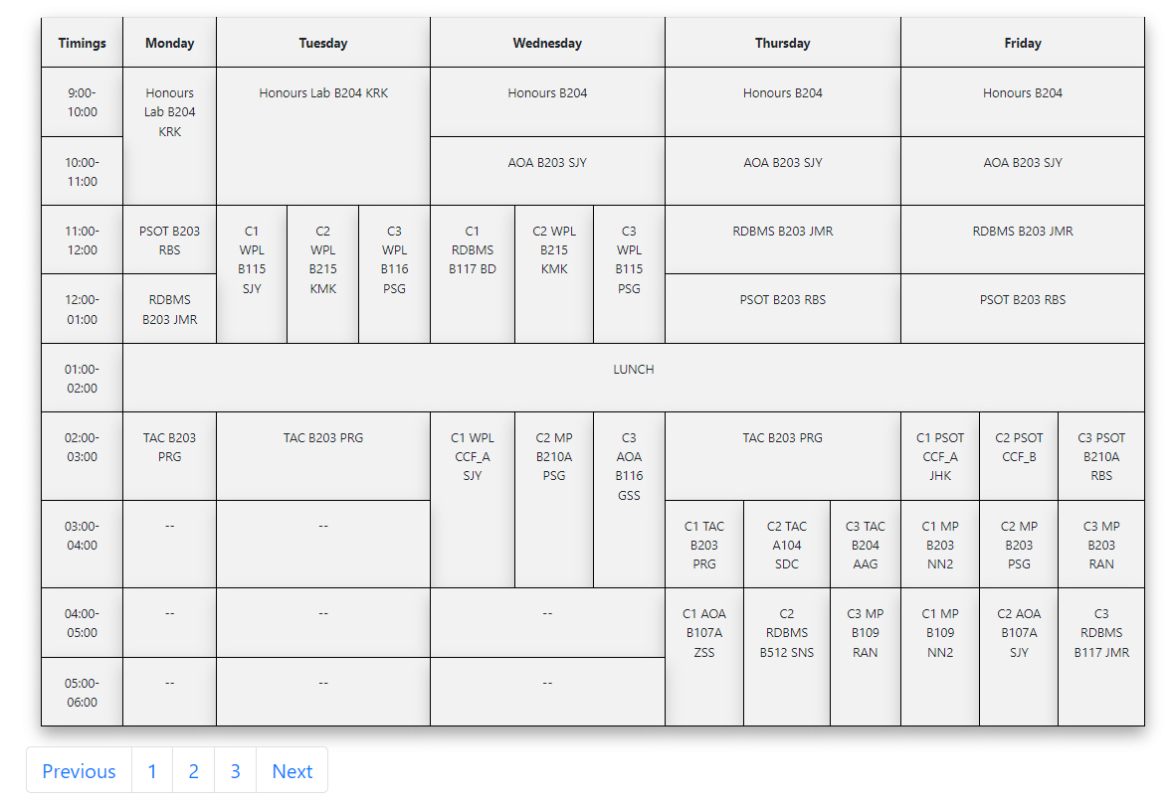

**Post Lab Questions:**

1. **What is the use of containers in bootstrap? Explain in detail.**

Containers

Containers are a fundamental building block of Bootstrap that contain, pad, and align your content within a given device or viewport.

* Containers are the most basic layout element in Bootstrap and are required when using our default grid system. Containers are used to contain, pad, and (sometimes) center the content within them. While containers can be nested, most layouts do not require a nested container.
* Bootstrap comes with three different containers:
  + - .container, which sets a max-width at each responsive breakpoint
    - .container-fluid, which is width: 100% at all breakpoints
    - .container-{breakpoint}, which is width: 100% until the specified breakpoint.
* Default container

Our default .container class is a responsive, fixed-width container, meaning its max-width changes at each breakpoint.

* Responsive containers

Responsive containers allow you to specify a class that is 100% wide until the specified breakpoint is reached, after which we apply max-widths for each of the higher breakpoints. For example, .container-sm is 100% wide to start until the sm breakpoint is reached, where it will scale up with md, lg, xl, and xxl.

* Fluid containers

Use .container-fluid for a full width container, spanning the entire width of the viewport.

## Sass

Bootstrap generates a series of predefined container classes to help you build the layouts you desire. You may customize these predefined container classes by modifying the Sass map (found in _variables.scss) that powers them

1. **Name the classes to achieve the different button styles in bootstrap.**

In Bootstrap, different button styles can be achieved using various classes. Here are some of the main classes used for button styling:

1. `.btn`: This is the base class for creating buttons in Bootstrap.

2. `.btn-primary`: This class is used for styling primary buttons, typically denoting the primary action in a page or form.

3. `.btn-secondary`: This class is used for styling secondary buttons, often used for less important actions or as alternatives to primary buttons.

4. `.btn-success`: This class is used for styling success-themed buttons, often used to indicate successful actions or positive outcomes.

5. `.btn-danger`: This class is used for styling buttons that signify dangerous or potentially negative actions.

6. `.btn-warning`: This class is used for styling warning-themed buttons, indicating caution or potential issues.

7. `.btn-info`: This class is used for styling informational buttons, often used for providing supplementary information or links.

8. `.btn-light`: This class is used for styling light-colored buttons, often used for neutral or less emphasized actions.

9. `.btn-dark`: This class is used for styling dark-colored buttons, providing a darker alternative to light-colored buttons.

10. `.btn-link`: This class is used for styling buttons that resemble links, typically used for actions that navigate or redirect the user.

These classes can be combined with other classes or customized further using additional CSS to achieve specific button styles as needed.

1. **Write details about the Bootstrap Grid system.**

Bootstrap’s grid system uses a series of containers, rows, and columns to layout and align content. It’s built with flexbox and is fully responsive. Below is an example and an in-depth look at how the grid comes together.

Certainly, here's the information about the Bootstrap Grid System without bold font:

The Bootstrap Grid System is a responsive, mobile-first grid system designed to provide a consistent and flexible layout structure for building websites and web applications. It allows developers to create responsive designs that adapt to various screen sizes and devices, ensuring a seamless user experience across different platforms.

1. Container: The outermost element that wraps the content of your website. Bootstrap offers two types of containers:

- .container: Fixed-width container that is centered horizontally.

- .container-fluid: Full-width container that spans the entire width of the viewport.

2. Rows: Horizontal containers for columns. Rows are used to ensure proper alignment and spacing of columns. Each row must be placed within a container.

3. Columns: Vertical containers for content, arranged horizontally within a row. Bootstrap provides a 12-column grid system, which can be divided into multiple fractions to create flexible layouts. Columns are defined using classes such as .col-{breakpoint}-{number}, where {breakpoint} specifies the screen size (e.g., xs for extra small, sm for small, md for medium, lg for large, xl for extra large) and {number} specifies the number of columns the element should span.

4. Offset: Classes such as .offset-{breakpoint}-{number} are used to create empty space (offset) before a column. This is useful for adjusting the layout and alignment of elements.

5. Nested Grids: Grids can be nested within columns to create more complex layouts. Nested grids follow the same structure as the main grid system, with containers, rows, and columns.

6. Responsive Classes: Bootstrap provides responsive classes for controlling column behavior at different screen sizes. These classes allow developers to create layouts that adapt to various devices, such as smartphones, tablets, and desktops.

7. Alignment and Ordering: Bootstrap offers classes for aligning content horizontally and vertically within columns (justify-content-*, align-items-*, align-self-*) and for controlling the order of columns (order-*).

By leveraging the Bootstrap Grid System, developers can create responsive and visually appealing layouts without the need for extensive custom CSS. The grid system provides a solid foundation for building modern web interfaces that work seamlessly across different devices and screen sizes.